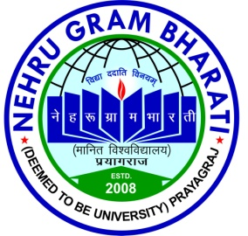

DEPARTMENT OF ……….
NEHRU GRAM BHARATI(DEEMED TO BE UNIVERSITY)
KOTWA- JAMUNIPUR, DUBAWAL, PRAYAGRAJ (U.P) INDIA

DECLARATION

I,…………………………………., Enrollment No: …………………. Certify that this thesis work entitled“…………………………………………………………………………….”is submitted by me in partial fulfillment of the requirement of the *Degree of Doctor of Philosophy/*P.G Dissertation in Department of ………………………………………………………………………..,Nehru Gram Bharati (Deemed to be University) Prayagraj.
I understand plagiarism includes:-
- Reproducing someone else’s work (fully or partially) or ideas and claiming it as one’s own.
- Reproducing someone else’s work (Verbatim copying or paraphrasing)
without crediting.
- Committing literary theft (copying some unique literary construct).
I have given due credit to the original authors/sources through proper citation for all the words, ideas, diagrams, graphics, computer programs, experiments, results, websites, that are not my original contribution. I have used quotation marks to identify verbatim sentences reproduced in italics and given credit to the original authors/sources.
I affirm that the present *Ph.D.thesis/*P.G Dissertation is I my original work and no portion of my work is plagiarized. In the event of a complaint of plagiarism, I shall be fully responsible. I understand that my Supervisor may not be in a position to verify that this work is not plagiarized.
.
Prayagraj ( U.P) India (Students Name & Roll No).
Date: - ………………………
_________
* Strikeout whichever is not applicable.

